Jordan Alexis Bramson ORT Collage
1/18/2016
Game Class:
The Hard Walkway

I want all of you to imagine that you are playing a regular game that is fun and possible. Now imagine that game and make it impossible, well that is the game that I want to show you today. The game pretty much start's up pretty much right off the back so you better start running or else. I want you all to rage quit before I tell you how to survive. I want the player to feel that all of your hope is lost. I mean I'm not the first person to make an “impossible” game. I used the most simple things from FPS I could find to use this so whatever I suppose.

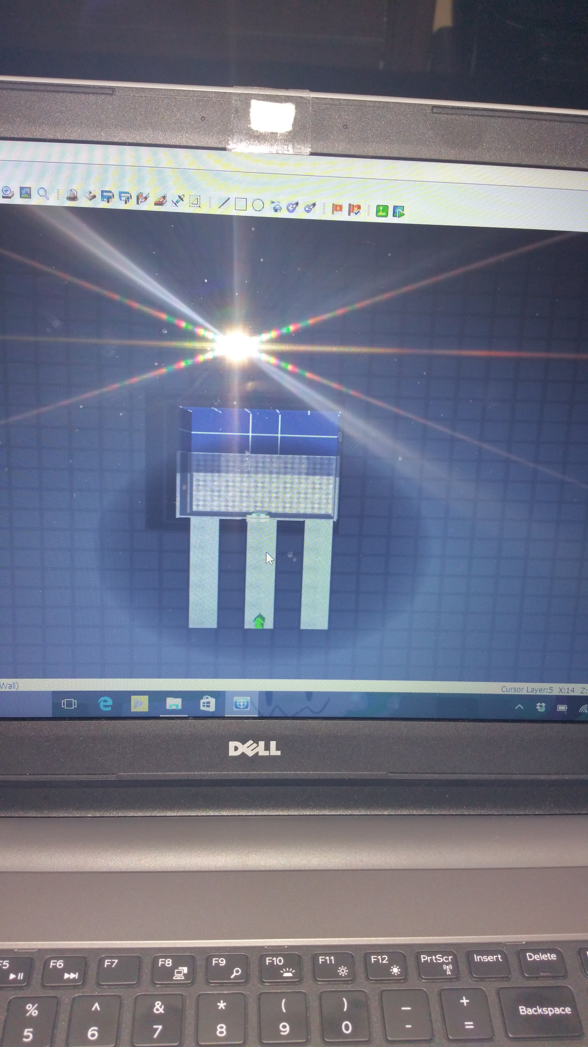
This First Picture shows what I made not so bad right?

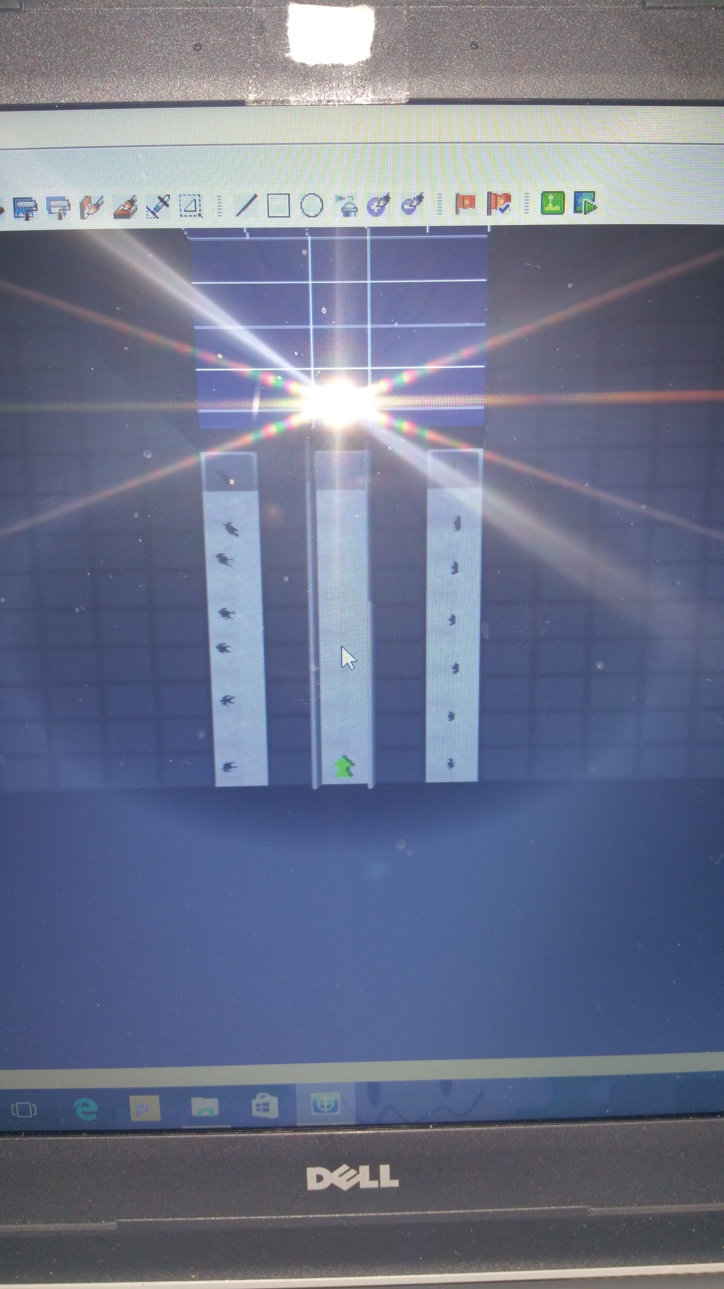
This Next picture shows you all the people that are going to ruin your life.

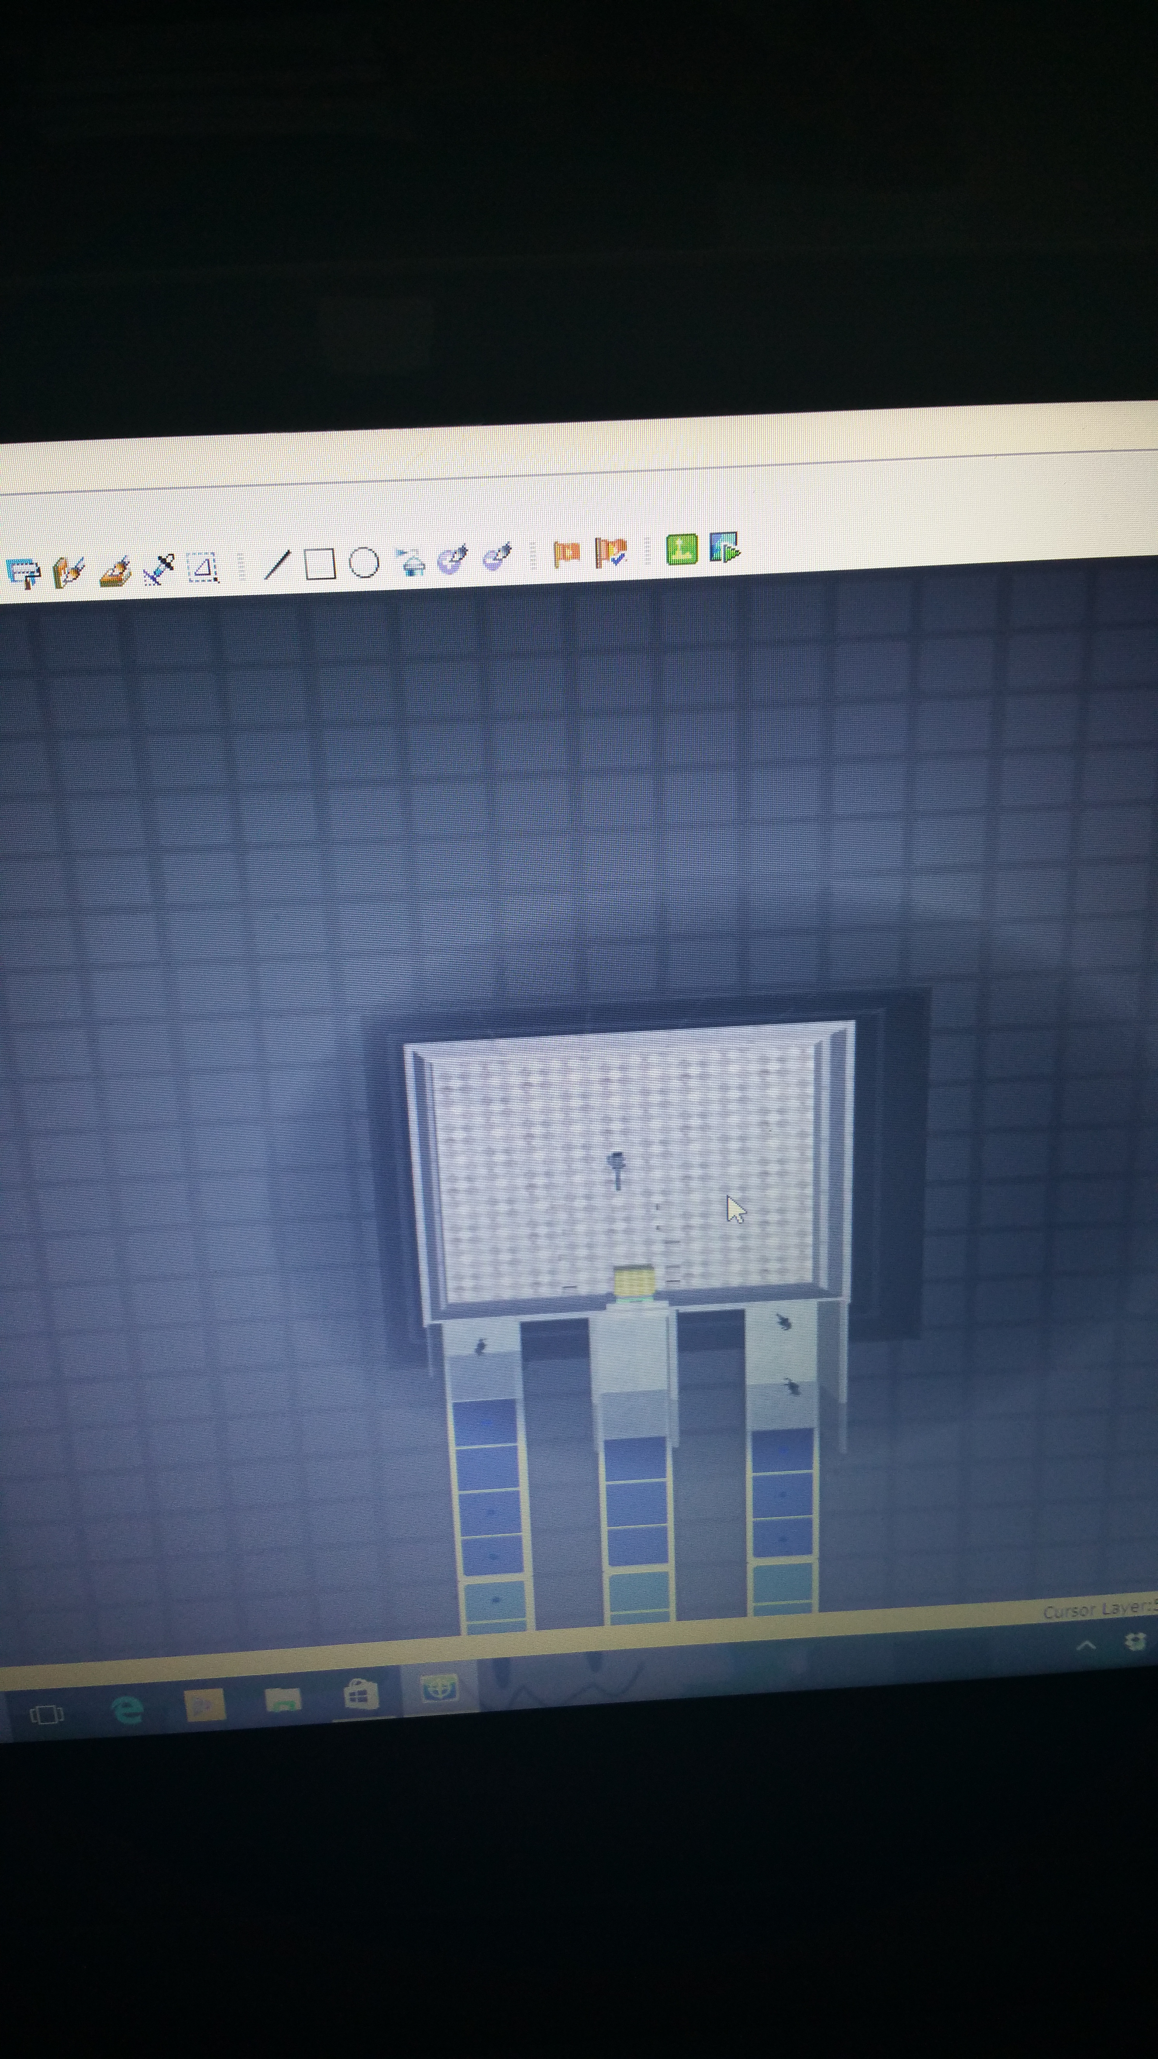
The next shows you the win zone, you may think that just running to it would be easy right well try running when you can go only as fast as maybe a turtle and bazookas coming at you from left and right. Also you may see some health and a machine gun why don't you try getting it.

Now lets hope that you can run cause “you're gonna need it”.

